Project Design Phase
Solution Architecture

Date | 02-07-2026
Team ID
Project Name | ONLINE COMPLAINT REGISTRATION
Maximum Marks | 4 Marks

Solution Architecture:
The solution architecture of the Online Complaint Registration defines the overall structure of the application and illustrates how different components interact to provide an efficient, secure, and transparent complaint management process. The system is developed using the MERN Stack (MongoDB, Express.js, React.js, and Node.js) and follows a client-server architecture to enable seamless communication between users, administrators, agents, and the database.
Its goals are to:
- Provide a secure and scalable web-based solution for online complaint registration, complaint assignment, real-time status tracking, complaint resolution, and feedback management.
- Describe the interaction between the frontend, backend, database, and external services, ensuring smooth communication among Users, Administrators, and Agents throughout the complaint lifecycle.
- Define the system modules, workflow, security mechanisms, and functional requirements, including user authentication, role-based access control, complaint management, chat, notifications, dashboard analytics, and resolution image uploads.
- Establish a well-structured architecture that supports efficient development, deployment, maintenance, and future enhancements while ensuring reliability, transparency, and improved user satisfaction.

Solution Architecture Diagram:

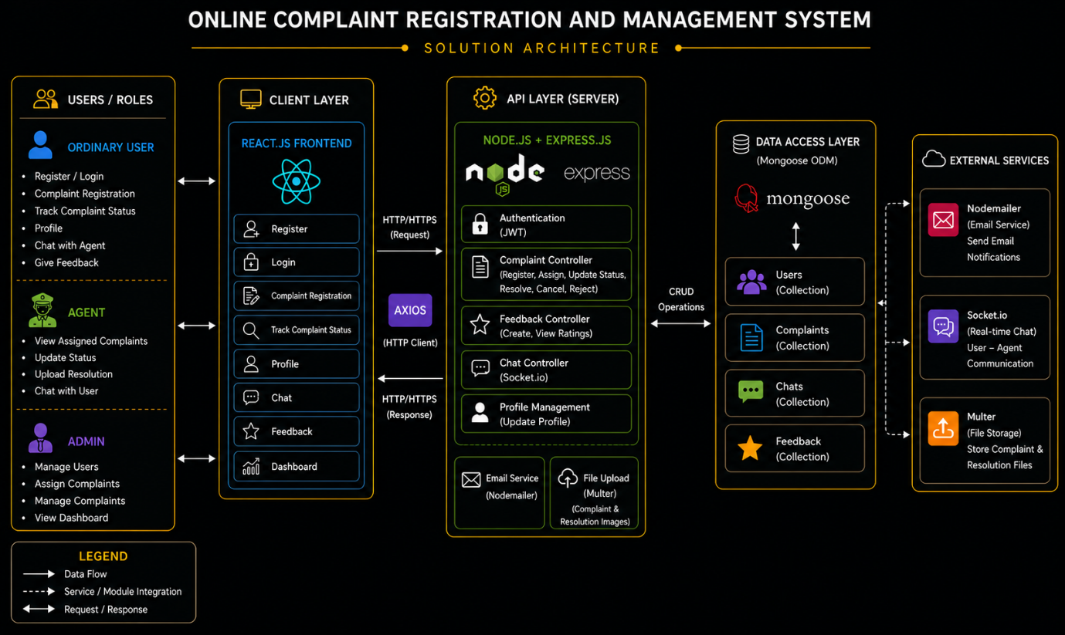
Figure 1: Architecture and data flow of the Online Complaint Registration
Reference: https://aws.amazon.com/blogs/industries/voice-applications-in-clinical-research-powered-by-ai-on-aws-part-1-architecture-and-design-considerations/

